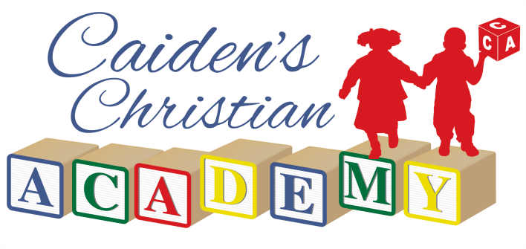

*4872 tf. State Street Jackson, tfS 39206 Phone:*

\**Childcare Registration, Permission & Liability Release*

Please read and sign the following statement:

I, , the legal guardian, and/or parent

of , declare that I have read and understand Caiden’s Christian Academy Admission Policies and Procedures as they are contained in this document as well as in the Parent Handbook.

Signature: Date:

*\*For Office Use Only*

Parent Orientation: Preferred Start Date: Application Received:

|  |  |  |
| --- | --- | --- |
| Wait List | Yes | No |
| $100 Deposit Received | Yes | No |
| Enrollment Received | Yes | No |
| First Month’s Fees Arranged | Yes | No |
| Subsidy Arranged | Yes | No |

Office Signature: Date:

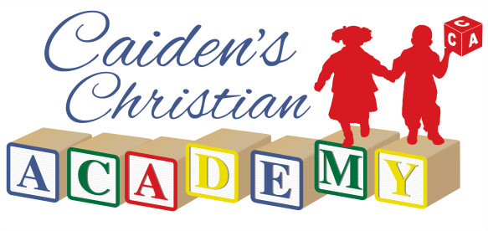

*\*Childcare Registration Today’s Date*

*Referred By Preferred Start Date*

|  |  |  |  |  |  |  |
| --- | --- | --- | --- | --- | --- | --- |
| ***About Your Chi*** | ***ld*** |  | | | | |
|  |  |  |  |  |  | *tf F* |
| First Name | M.I. |  | Last Name |  | Preferred Name |  |
| Address |  | City |  | State |  | Zip Code |
| Church Attending |  |  | Pastor’s Name |  | Religious Preference |  |

|  |  |  |  |  |
| --- | --- | --- | --- | --- |
| Date of Birth School Attending Grade  ***Schedule***  Monday Tuesday Wednesday | | Teacher  Thursday | Friday | Room # |
| IN: IN: | IN: | IN:_ | IN: | |
| OUT: OUT: | OUT: | OUT: | OUT: | |
| ***About Your Family***  Parent/Guardian |  | Parent/Guardian |  | |
| First Name Middle | Last Name | First Name Middle | Last Name | |
| Cell Work | Home | Cell Work | Home | |
| Occupation | Work Email | Occupation | Work Email | |

# *More About Your Child*

type(s) of food is your child allergic to? .

Does your child eat table food? . What food does your child like and/or dislike? _. What type of formula does your infant use? Amounts given: . Time between feedings: Will your child drink from a bottle or cup? . Does your infant’s milk or food need to be heated? **Y** or **N**

Does your child sleep during the day? **Y** or **N**, When? For How Long? .

Is there any other information about your child that would be helpful for the staff to know in order to take better care of your child? (Please attach additional sheets if needed).

# *About Your Child’s Health*

Does your child take any prescribed medications? **Y** or **N**

Does your child have any allergies? **Y** or **N**

If yes, please explain in detail:

Is your toddler toilet trained? **Y** or **N**

Is your toddler currently learning to use the toilet? **Y** or **N**

If not, at what age do you want your child to begin toilet training? Will your toddler tell a staff member when they need to use the restroom? **Y** or **N**

## Please list any special needs your child may have:

Is your child immunized? **Y** or **N**

*A copy of your child’s immunization record must be submitted with these registration forms.

## *If your child is not immunized, please read and sign the following statement:

**I understand that should there be a suspected or real outbreak/pandemic of any communicable disease, I may have to remove my child from Caiden’s Christian Academy until cleared by medical staff; preferably the child’s Pediatrician.**

Signature: Date:

# *About Your Child’s Safety*

Please list anyone not previously listed who is authorized to pick your child up. Identification will be required at the time of pick up. Indicate if the person listed may also be contacted in case of an emergency.

Emergency

Name Relationship to Child Home # Work # Cell # Contact?

**Y** or **N**

**Y** or **N**

**Y** or **N**

## Y or N Are there any CUSTODY restrictions? Y or N

*If yes, a copy of the court order and any restrictions must be submitted with these registration forms.

### *Permission Forms*

1. I hereby give permission for my child to go on field trips arranged by Caiden’s Christian Academy staff. I understand that I will be informed in advance of any special field trips. Parent/Guardian Signature Date
2. I hereby give permission for pictures and/or videos to be taken of my child in the program setting for general record-keeping purposes.

Parent/Guardian Signature Date

1. I hereby give permission for sunscreen to be applied to my child prior to outdoor activities and/or some type of repellant.

Parent/Guardian Signature Date

1. On occasion, Caiden’s Christian Academy may receive requests from other professionals or by the community to observe the program(s). We attempt to do this with the least disturbance to the children’s routine. I hereby give permission for my child to be present on these occasions.

Parent/Guardian Signature Date

# *Liability Release Form*

In consideration of allowing the previously declared participant(s) to begin participation in Caiden’s Christian Academy activities, while on the premises and property of said Center, the

undersigned, for themselves, and/or being the legal and acting guardian of participant(s), acting for themselves and on behalf of the participant(s), release and hold harmless Caiden’s Christian Academy LLC, its owners, employees, and agents of and from any and all liability, claims, demands, and causes of action whatsoever, arising out of or related to any loss, damage, or injury, including death, that may be sustained by the participant and/or the undersigned, while in or upon the premises upon which Caiden’s Christian Academy is conducted, or any premises under the control and supervision of Caiden’s Christian Academy, its owners, officers, employees, or agents or in route to or from any of the said premises, or while at any premises or place when activities sponsored by or participated in by Caiden’s Christian Academy, its owners, officers, agents, or employees.

Parent/Guardian Signature Date

# *Assumption of Risk*

Participation in physical activities can involve motion, rotation, and height in a unique environment and as such carries with it a certain assumption of risk. The undersigned and the participant(s) choose to voluntarily enter upon said premises under the control of said limited liability company, knowing their present condition and knowing that said condition might become more hazardous and dangerous during the time the participant or the undersigned is upon said premises. The undersigned and the particpants(s) voluntarily assume any and all risks of loss, damage, or injury that may be sustained by the participants(s) and/or the undersigned or any property owner by them while on or upon said premises above. The limited liability company may, but shall not be obliged to carry insurance on the participant(s) and the existence of insurance shall not change, alter, or increase the liability of the LLC to the participant(s) and the undersigned or affect the terms of this Release. In signing the Release, the undersigned acknowledges:

* 1. That they have read thoroughly, understands completely the terms of Registration and Release, and signs it voluntarily.
  2. That the undersigned signing either for themselves, or as Legal Guardian is, in fact, the true and legal guardian and has the consent of the participant(s).

Parent/Guardian Signature Date

*A copy of the following section will be carried with a Caiden’s Christian Academy staff member when transporting your child.

# *Medical Release*

The undersigned gives permission for Caiden’s Christian Academy owners, employees, and/or agents to seek emergency medical treatment for the participant(s) in the event they are unable to reach any parent or guardian. The undersigned also agrees they themselves will be responsible for any financial debt incurred by said action.

Parent/Guardian Signature Date

# *Transportation Release*

I give permission for my child to be transported either by Caiden’s Christian Academy or by other commercial or public transportation for field trips or to school/afterschool.

Parent/Guardian Signature Date

M F Child’s First Name M.I. Last Name Preferred Name

Parent/Guardian First Name Last Name Cell # Home #

### *\*Quality Education with a Spiritual Foundation\**